|  |
| --- |
| The SAS System |

The UNIVARIATE Procedure

Variable: M

| **Moments** | | | |
| --- | --- | --- | --- |
| **N** | 47 | **Sum Weights** | 47 |
| **Mean** | 13.8574468 | **Sum Observations** | 651.3 |
| **Std Deviation** | 1.25676339 | **Variance** | 1.57945421 |
| **Skewness** | 0.87710806 | **Kurtosis** | 0.72619579 |
| **Uncorrected SS** | 9098.01 | **Corrected SS** | 72.6548936 |
| **Coeff Variation** | 9.06922757 | **Std Error Mean** | 0.18331778 |

| **Basic Statistical Measures** | | | |
| --- | --- | --- | --- |
| **Location** | | **Variability** | |
| **Mean** | 13.85745 | **Std Deviation** | 1.25676 |
| **Median** | 13.60000 | **Variance** | 1.57945 |
| **Mode** | 12.60000 | **Range** | 5.80000 |
|  |  | **Interquartile Range** | 1.70000 |

|  |
| --- |
| **Note: The mode displayed is the smallest of 4 modes with a count of 3.** |

| **Tests for Location: Mu0=0** | | | | |
| --- | --- | --- | --- | --- |
| **Test** | **Statistic** | | **p Value** | |
| **Student's t** | **t** | 75.59249 | **Pr > |t|** | <.0001 |
| **Sign** | **M** | 23.5 | **Pr >= |M|** | <.0001 |
| **Signed Rank** | **S** | 564 | **Pr >= |S|** | <.0001 |

| **Quantiles (Definition 5)** | |
| --- | --- |
| **Level** | **Quantile** |
| **100% Max** | 17.7 |
| **99%** | 17.7 |
| **95%** | 16.2 |
| **90%** | 15.7 |
| **75% Q3** | 14.7 |
| **50% Median** | 13.6 |
| **25% Q1** | 13.0 |
| **10%** | 12.5 |
| **5%** | 12.3 |
| **1%** | 11.9 |
| **0% Min** | 11.9 |

| **Extreme Observations** | | | |
| --- | --- | --- | --- |
| **Lowest** | | **Highest** | |
| **Value** | **Obs** | **Value** | **Obs** |
| 11.9 | 29 | 15.7 | 9 |
| 12.1 | 6 | 15.7 | 22 |
| 12.3 | 35 | 16.2 | 43 |
| 12.4 | 11 | 16.6 | 30 |
| 12.5 | 32 | 17.7 | 37 |

|  |
| --- |
| The SAS System |

The UNIVARIATE Procedure

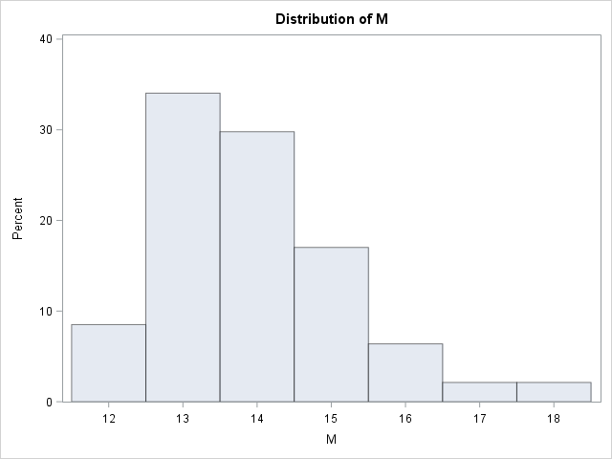

|  |
| --- |
| The SAS System |

The UNIVARIATE Procedure

Variable: So

| **Moments** | | | |
| --- | --- | --- | --- |
| **N** | 47 | **Sum Weights** | 47 |
| **Mean** | 0.34042553 | **Sum Observations** | 16 |
| **Std Deviation** | 0.47897516 | **Variance** | 0.22941721 |
| **Skewness** | 0.69593031 | **Kurtosis** | -1.585044 |
| **Uncorrected SS** | 16 | **Corrected SS** | 10.5531915 |
| **Coeff Variation** | 140.698954 | **Std Error Mean** | 0.06986571 |

| **Basic Statistical Measures** | | | |
| --- | --- | --- | --- |
| **Location** | | **Variability** | |
| **Mean** | 0.340426 | **Std Deviation** | 0.47898 |
| **Median** | 0.000000 | **Variance** | 0.22942 |
| **Mode** | 0.000000 | **Range** | 1.00000 |
|  |  | **Interquartile Range** | 1.00000 |

| **Tests for Location: Mu0=0** | | | | |
| --- | --- | --- | --- | --- |
| **Test** | **Statistic** | | **p Value** | |
| **Student's t** | **t** | 4.87257 | **Pr > |t|** | <.0001 |
| **Sign** | **M** | 8 | **Pr >= |M|** | <.0001 |
| **Signed Rank** | **S** | 68 | **Pr >= |S|** | <.0001 |

| **Quantiles (Definition 5)** | |
| --- | --- |
| **Level** | **Quantile** |
| **100% Max** | 1 |
| **99%** | 1 |
| **95%** | 1 |
| **90%** | 1 |
| **75% Q3** | 1 |
| **50% Median** | 0 |
| **25% Q1** | 0 |
| **10%** | 0 |
| **5%** | 0 |
| **1%** | 0 |
| **0% Min** | 0 |

| **Extreme Observations** | | | |
| --- | --- | --- | --- |
| **Lowest** | | **Highest** | |
| **Value** | **Obs** | **Value** | **Obs** |
| 0 | 47 | 1 | 37 |
| 0 | 46 | 1 | 39 |
| 0 | 44 | 1 | 40 |
| 0 | 42 | 1 | 43 |
| 0 | 41 | 1 | 45 |

|  |
| --- |
| The SAS System |

The UNIVARIATE Procedure

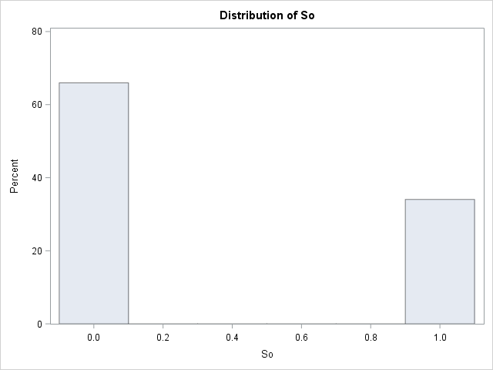

|  |
| --- |
| The SAS System |

The UNIVARIATE Procedure

Variable: Ed

| **Moments** | | | |
| --- | --- | --- | --- |
| **N** | 47 | **Sum Weights** | 47 |
| **Mean** | 10.5638298 | **Sum Observations** | 496.5 |
| **Std Deviation** | 1.11869985 | **Variance** | 1.25148936 |
| **Skewness** | -0.3404072 | **Kurtosis** | -1.0514892 |
| **Uncorrected SS** | 5302.51 | **Corrected SS** | 57.5685106 |
| **Coeff Variation** | 10.589908 | **Std Error Mean** | 0.16317914 |

| **Basic Statistical Measures** | | | |
| --- | --- | --- | --- |
| **Location** | | **Variability** | |
| **Mean** | 10.56383 | **Std Deviation** | 1.11870 |
| **Median** | 10.80000 | **Variance** | 1.25149 |
| **Mode** | 10.40000 | **Range** | 3.50000 |
|  |  | **Interquartile Range** | 2.00000 |

|  |
| --- |
| **Note: The mode displayed is the smallest of 2 modes with a count of 5.** |

| **Tests for Location: Mu0=0** | | | | |
| --- | --- | --- | --- | --- |
| **Test** | **Statistic** | | **p Value** | |
| **Student's t** | **t** | 64.73762 | **Pr > |t|** | <.0001 |
| **Sign** | **M** | 23.5 | **Pr >= |M|** | <.0001 |
| **Signed Rank** | **S** | 564 | **Pr >= |S|** | <.0001 |

| **Quantiles (Definition 5)** | |
| --- | --- |
| **Level** | **Quantile** |
| **100% Max** | 12.2 |
| **99%** | 12.2 |
| **95%** | 12.1 |
| **90%** | 12.1 |
| **75% Q3** | 11.6 |
| **50% Median** | 10.8 |
| **25% Q1** | 9.6 |
| **10%** | 8.8 |
| **5%** | 8.8 |
| **1%** | 8.7 |
| **0% Min** | 8.7 |

| **Extreme Observations** | | | |
| --- | --- | --- | --- |
| **Lowest** | | **Highest** | |
| **Value** | **Obs** | **Value** | **Obs** |
| 8.7 | 37 | 12.1 | 5 |
| 8.7 | 15 | 12.1 | 26 |
| 8.8 | 45 | 12.1 | 44 |
| 8.8 | 39 | 12.1 | 47 |
| 8.8 | 16 | 12.2 | 41 |

|  |
| --- |
| The SAS System |

The UNIVARIATE Procedure

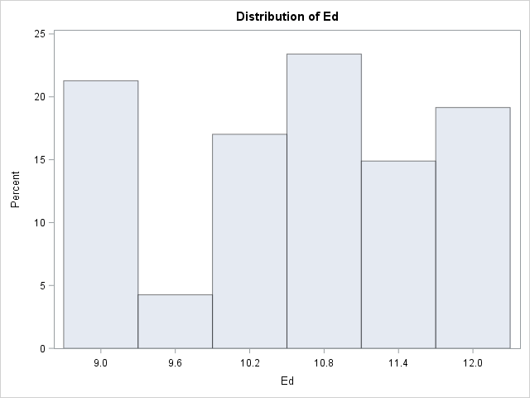

|  |
| --- |
| The SAS System |

The UNIVARIATE Procedure

Variable: Po1

| **Moments** | | | |
| --- | --- | --- | --- |
| **N** | 47 | **Sum Weights** | 47 |
| **Mean** | 8.5 | **Sum Observations** | 399.5 |
| **Std Deviation** | 2.97189736 | **Variance** | 8.83217391 |
| **Skewness** | 0.94989564 | **Kurtosis** | 0.47538371 |
| **Uncorrected SS** | 3802.03 | **Corrected SS** | 406.28 |
| **Coeff Variation** | 34.9634983 | **Std Error Mean** | 0.43349578 |

| **Basic Statistical Measures** | | | |
| --- | --- | --- | --- |
| **Location** | | **Variability** | |
| **Mean** | 8.500000 | **Std Deviation** | 2.97190 |
| **Median** | 7.800000 | **Variance** | 8.83217 |
| **Mode** | 5.800000 | **Range** | 12.10000 |
|  |  | **Interquartile Range** | 4.40000 |

|  |
| --- |
| **Note: The mode displayed is the smallest of 2 modes with a count of 3.** |

| **Tests for Location: Mu0=0** | | | | |
| --- | --- | --- | --- | --- |
| **Test** | **Statistic** | | **p Value** | |
| **Student's t** | **t** | 19.60803 | **Pr > |t|** | <.0001 |
| **Sign** | **M** | 23.5 | **Pr >= |M|** | <.0001 |
| **Signed Rank** | **S** | 564 | **Pr >= |S|** | <.0001 |

| **Quantiles (Definition 5)** | |
| --- | --- |
| **Level** | **Quantile** |
| **100% Max** | 16.6 |
| **99%** | 16.6 |
| **95%** | 14.9 |
| **90%** | 12.3 |
| **75% Q3** | 10.6 |
| **50% Median** | 7.8 |
| **25% Q1** | 6.2 |
| **10%** | 5.5 |
| **5%** | 4.7 |
| **1%** | 4.5 |
| **0% Min** | 4.5 |

| **Extreme Observations** | | | |
| --- | --- | --- | --- |
| **Lowest** | | **Highest** | |
| **Value** | **Obs** | **Value** | **Obs** |
| 4.5 | 3 | 12.3 | 18 |
| 4.6 | 45 | 12.8 | 19 |
| 4.7 | 22 | 14.9 | 4 |
| 5.1 | 38 | 16.0 | 26 |
| 5.5 | 31 | 16.6 | 29 |

|  |
| --- |
| The SAS System |

The UNIVARIATE Procedure

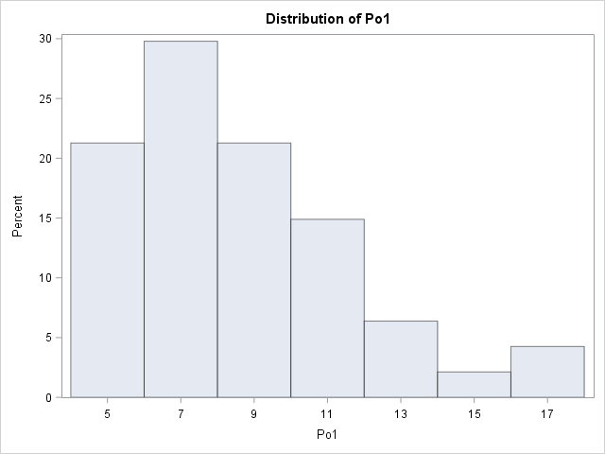

|  |
| --- |
| The SAS System |

The UNIVARIATE Procedure

Variable: Po2

| **Moments** | | | |
| --- | --- | --- | --- |
| **N** | 47 | **Sum Weights** | 47 |
| **Mean** | 8.02340426 | **Sum Observations** | 377.1 |
| **Std Deviation** | 2.79613186 | **Variance** | 7.81835338 |
| **Skewness** | 0.90106575 | **Kurtosis** | 0.29642968 |
| **Uncorrected SS** | 3385.27 | **Corrected SS** | 359.644255 |
| **Coeff Variation** | 34.8496944 | **Std Error Mean** | 0.40785775 |

| **Basic Statistical Measures** | | | |
| --- | --- | --- | --- |
| **Location** | | **Variability** | |
| **Mean** | 8.023404 | **Std Deviation** | 2.79613 |
| **Median** | 7.300000 | **Variance** | 7.81835 |
| **Mode** | 5.400000 | **Range** | 11.60000 |
|  |  | **Interquartile Range** | 4.00000 |

| **Tests for Location: Mu0=0** | | | | |
| --- | --- | --- | --- | --- |
| **Test** | **Statistic** | | **p Value** | |
| **Student's t** | **t** | 19.67207 | **Pr > |t|** | <.0001 |
| **Sign** | **M** | 23.5 | **Pr >= |M|** | <.0001 |
| **Signed Rank** | **S** | 564 | **Pr >= |S|** | <.0001 |

| **Quantiles (Definition 5)** | |
| --- | --- |
| **Level** | **Quantile** |
| **100% Max** | 15.7 |
| **99%** | 15.7 |
| **95%** | 14.1 |
| **90%** | 11.6 |
| **75% Q3** | 9.7 |
| **50% Median** | 7.3 |
| **25% Q1** | 5.7 |
| **10%** | 5.3 |
| **5%** | 4.4 |
| **1%** | 4.1 |
| **0% Min** | 4.1 |

| **Extreme Observations** | | | |
| --- | --- | --- | --- |
| **Lowest** | | **Highest** | |
| **Value** | **Obs** | **Value** | **Obs** |
| 4.1 | 45 | 11.6 | 11 |
| 4.4 | 22 | 12.8 | 19 |
| 4.4 | 3 | 14.1 | 4 |
| 4.7 | 38 | 14.3 | 26 |
| 5.3 | 15 | 15.7 | 29 |

|  |
| --- |
| The SAS System |

The UNIVARIATE Procedure

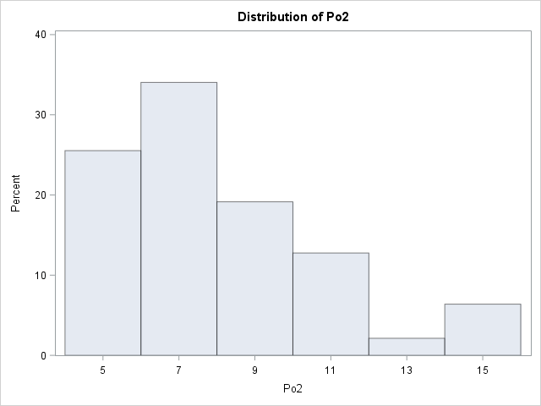

|  |
| --- |
| The SAS System |

The UNIVARIATE Procedure

Variable: LF

| **Moments** | | | |
| --- | --- | --- | --- |
| **N** | 47 | **Sum Weights** | 47 |
| **Mean** | 0.56119149 | **Sum Observations** | 26.376 |
| **Std Deviation** | 0.04041181 | **Variance** | 0.00163311 |
| **Skewness** | 0.28885057 | **Kurtosis** | -0.7482002 |
| **Uncorrected SS** | 14.87711 | **Corrected SS** | 0.07512328 |
| **Coeff Variation** | 7.20107392 | **Std Error Mean** | 0.00589467 |

| **Basic Statistical Measures** | | | |
| --- | --- | --- | --- |
| **Location** | | **Variability** | |
| **Mean** | 0.561191 | **Std Deviation** | 0.04041 |
| **Median** | 0.560000 | **Variance** | 0.00163 |
| **Mode** | 0.521000 | **Range** | 0.16100 |
|  |  | **Interquartile Range** | 0.06500 |

|  |
| --- |
| **Note: The mode displayed is the smallest of 7 modes with a count of 2.** |

| **Tests for Location: Mu0=0** | | | | |
| --- | --- | --- | --- | --- |
| **Test** | **Statistic** | | **p Value** | |
| **Student's t** | **t** | 95.20322 | **Pr > |t|** | <.0001 |
| **Sign** | **M** | 23.5 | **Pr >= |M|** | <.0001 |
| **Signed Rank** | **S** | 564 | **Pr >= |S|** | <.0001 |

| **Quantiles (Definition 5)** | |
| --- | --- |
| **Level** | **Quantile** |
| **100% Max** | 0.641 |
| **99%** | 0.641 |
| **95%** | 0.632 |
| **90%** | 0.624 |
| **75% Q3** | 0.595 |
| **50% Median** | 0.560 |
| **25% Q1** | 0.530 |
| **10%** | 0.515 |
| **5%** | 0.510 |
| **1%** | 0.480 |
| **0% Min** | 0.480 |

| **Extreme Observations** | | | |
| --- | --- | --- | --- |
| **Lowest** | | **Highest** | |
| **Value** | **Obs** | **Value** | **Obs** |
| 0.480 | 45 | 0.624 | 13 |
| 0.497 | 16 | 0.631 | 26 |
| 0.510 | 1 | 0.632 | 10 |
| 0.512 | 22 | 0.638 | 37 |
| 0.515 | 39 | 0.641 | 25 |

|  |
| --- |
| The SAS System |

The UNIVARIATE Procedure

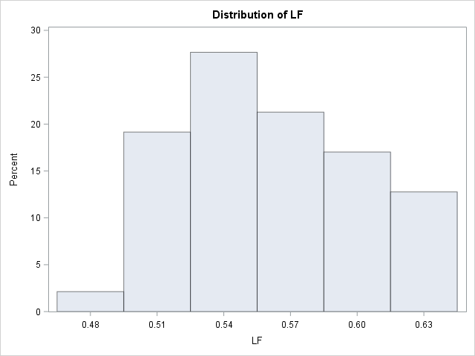

|  |
| --- |
| The SAS System |

The UNIVARIATE Procedure

Variable: MpF

| **Moments** | | | |
| --- | --- | --- | --- |
| **N** | 47 | **Sum Weights** | 47 |
| **Mean** | 98.3021277 | **Sum Observations** | 4620.2 |
| **Std Deviation** | 2.94673654 | **Variance** | 8.68325624 |
| **Skewness** | 1.05991756 | **Kurtosis** | 1.0454756 |
| **Uncorrected SS** | 454574.92 | **Corrected SS** | 399.429787 |
| **Coeff Variation** | 2.99763251 | **Std Error Mean** | 0.4298257 |

| **Basic Statistical Measures** | | | |
| --- | --- | --- | --- |
| **Location** | | **Variability** | |
| **Mean** | 98.30213 | **Std Deviation** | 2.94674 |
| **Median** | 97.70000 | **Variance** | 8.68326 |
| **Mode** | 96.40000 | **Range** | 13.70000 |
|  |  | **Interquartile Range** | 3.00000 |

|  |
| --- |
| **Note: The mode displayed is the smallest of 2 modes with a count of 3.** |

| **Tests for Location: Mu0=0** | | | | |
| --- | --- | --- | --- | --- |
| **Test** | **Statistic** | | **p Value** | |
| **Student's t** | **t** | 228.7023 | **Pr > |t|** | <.0001 |
| **Sign** | **M** | 23.5 | **Pr >= |M|** | <.0001 |
| **Signed Rank** | **S** | 564 | **Pr >= |S|** | <.0001 |

| **Quantiles (Definition 5)** | |
| --- | --- |
| **Level** | **Quantile** |
| **100% Max** | 107.1 |
| **99%** | 107.1 |
| **95%** | 104.5 |
| **90%** | 102.9 |
| **75% Q3** | 99.4 |
| **50% Median** | 97.7 |
| **25% Q1** | 96.4 |
| **10%** | 95.3 |
| **5%** | 94.8 |
| **1%** | 93.4 |
| **0% Min** | 93.4 |

| **Extreme Observations** | | | |
| --- | --- | --- | --- |
| **Lowest** | | **Highest** | |
| **Value** | **Obs** | **Value** | **Obs** |
| 93.4 | 19 | 102.9 | 10 |
| 93.8 | 29 | 103.8 | 24 |
| 94.8 | 35 | 104.5 | 31 |
| 95.0 | 1 | 104.9 | 47 |
| 95.3 | 39 | 107.1 | 26 |

|  |
| --- |
| The SAS System |

The UNIVARIATE Procedure

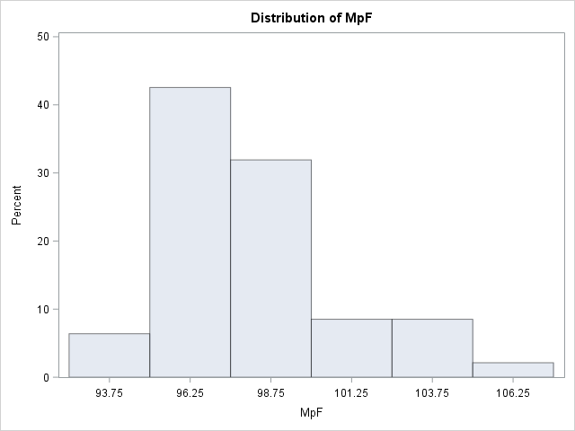

|  |
| --- |
| The SAS System |

The UNIVARIATE Procedure

Variable: Pop

| **Moments** | | | |
| --- | --- | --- | --- |
| **N** | 47 | **Sum Weights** | 47 |
| **Mean** | 36.6170213 | **Sum Observations** | 1721 |
| **Std Deviation** | 38.071188 | **Variance** | 1449.41536 |
| **Skewness** | 1.97874126 | **Kurtosis** | 3.8708135 |
| **Uncorrected SS** | 129691 | **Corrected SS** | 66673.1064 |
| **Coeff Variation** | 103.971286 | **Std Error Mean** | 5.55325351 |

| **Basic Statistical Measures** | | | |
| --- | --- | --- | --- |
| **Location** | | **Variability** | |
| **Mean** | 36.61702 | **Std Deviation** | 38.07119 |
| **Median** | 25.00000 | **Variance** | 1449 |
| **Mode** | 7.00000 | **Range** | 165.00000 |
|  |  | **Interquartile Range** | 33.00000 |

|  |
| --- |
| **Note: The mode displayed is the smallest of 2 modes with a count of 3.** |

| **Tests for Location: Mu0=0** | | | | |
| --- | --- | --- | --- | --- |
| **Test** | **Statistic** | | **p Value** | |
| **Student's t** | **t** | 6.593796 | **Pr > |t|** | <.0001 |
| **Sign** | **M** | 23.5 | **Pr >= |M|** | <.0001 |
| **Signed Rank** | **S** | 564 | **Pr >= |S|** | <.0001 |

| **Quantiles (Definition 5)** | |
| --- | --- |
| **Level** | **Quantile** |
| **100% Max** | 168 |
| **99%** | 168 |
| **95%** | 113 |
| **90%** | 97 |
| **75% Q3** | 43 |
| **50% Median** | 25 |
| **25% Q1** | 10 |
| **10%** | 6 |
| **5%** | 4 |
| **1%** | 3 |
| **0% Min** | 3 |

| **Extreme Observations** | | | |
| --- | --- | --- | --- |
| **Lowest** | | **Highest** | |
| **Value** | **Obs** | **Value** | **Obs** |
| 3 | 47 | 97 | 32 |
| 3 | 26 | 101 | 11 |
| 4 | 42 | 113 | 35 |
| 4 | 7 | 157 | 4 |
| 6 | 31 | 168 | 29 |

|  |
| --- |
| The SAS System |

The UNIVARIATE Procedure

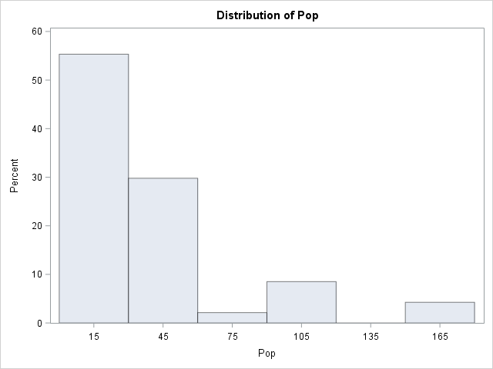

|  |
| --- |
| The SAS System |

The UNIVARIATE Procedure

Variable: NW

| **Moments** | | | |
| --- | --- | --- | --- |
| **N** | 47 | **Sum Weights** | 47 |
| **Mean** | 10.112766 | **Sum Observations** | 475.3 |
| **Std Deviation** | 10.2828819 | **Variance** | 105.73766 |
| **Skewness** | 1.47263081 | **Kurtosis** | 1.54098768 |
| **Uncorrected SS** | 9670.53 | **Corrected SS** | 4863.93234 |
| **Coeff Variation** | 101.68219 | **Std Error Mean** | 1.49991248 |

| **Basic Statistical Measures** | | | |
| --- | --- | --- | --- |
| **Location** | | **Variability** | |
| **Mean** | 10.11277 | **Std Deviation** | 10.28288 |
| **Median** | 7.60000 | **Variance** | 105.73766 |
| **Mode** | 2.40000 | **Range** | 42.10000 |
|  |  | **Interquartile Range** | 11.50000 |

| **Tests for Location: Mu0=0** | | | | |
| --- | --- | --- | --- | --- |
| **Test** | **Statistic** | | **p Value** | |
| **Student's t** | **t** | 6.742237 | **Pr > |t|** | <.0001 |
| **Sign** | **M** | 23.5 | **Pr >= |M|** | <.0001 |
| **Signed Rank** | **S** | 564 | **Pr >= |S|** | <.0001 |

| **Quantiles (Definition 5)** | |
| --- | --- |
| **Level** | **Quantile** |
| **100% Max** | 42.3 |
| **99%** | 42.3 |
| **95%** | 32.1 |
| **90%** | 28.6 |
| **75% Q3** | 13.9 |
| **50% Median** | 7.6 |
| **25% Q1** | 2.4 |
| **10%** | 1.2 |
| **5%** | 0.6 |
| **1%** | 0.2 |
| **0% Min** | 0.2 |

| **Extreme Observations** | | | |
| --- | --- | --- | --- |
| **Lowest** | | **Highest** | |
| **Value** | **Obs** | **Value** | **Obs** |
| 0.2 | 42 | 28.6 | 9 |
| 0.4 | 27 | 30.1 | 1 |
| 0.6 | 17 | 32.1 | 16 |
| 1.0 | 13 | 34.9 | 37 |
| 1.2 | 21 | 42.3 | 22 |

|  |
| --- |
| The SAS System |

The UNIVARIATE Procedure

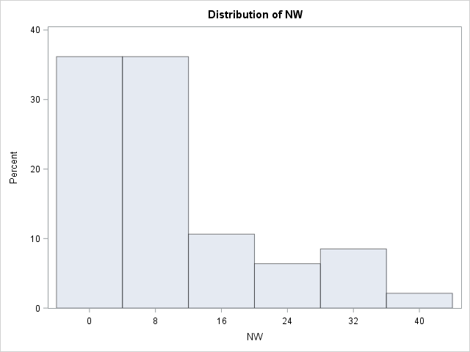

|  |
| --- |
| The SAS System |

The UNIVARIATE Procedure

Variable: U1

| **Moments** | | | |
| --- | --- | --- | --- |
| **N** | 47 | **Sum Weights** | 47 |
| **Mean** | 0.09546809 | **Sum Observations** | 4.487 |
| **Std Deviation** | 0.01802878 | **Variance** | 0.00032504 |
| **Skewness** | 0.8269089 | **Kurtosis** | 0.13368193 |
| **Uncorrected SS** | 0.443317 | **Corrected SS** | 0.0149517 |
| **Coeff Variation** | 18.8846174 | **Std Error Mean** | 0.00262977 |

| **Basic Statistical Measures** | | | |
| --- | --- | --- | --- |
| **Location** | | **Variability** | |
| **Mean** | 0.095468 | **Std Deviation** | 0.01803 |
| **Median** | 0.092000 | **Variance** | 0.0003250 |
| **Mode** | 0.102000 | **Range** | 0.07200 |
|  |  | **Interquartile Range** | 0.02500 |

| **Tests for Location: Mu0=0** | | | | |
| --- | --- | --- | --- | --- |
| **Test** | **Statistic** | | **p Value** | |
| **Student's t** | **t** | 36.30285 | **Pr > |t|** | <.0001 |
| **Sign** | **M** | 23.5 | **Pr >= |M|** | <.0001 |
| **Signed Rank** | **S** | 564 | **Pr >= |S|** | <.0001 |

| **Quantiles (Definition 5)** | |
| --- | --- |
| **Level** | **Quantile** |
| **100% Max** | 0.142 |
| **99%** | 0.142 |
| **95%** | 0.135 |
| **90%** | 0.124 |
| **75% Q3** | 0.105 |
| **50% Median** | 0.092 |
| **25% Q1** | 0.080 |
| **10%** | 0.076 |
| **5%** | 0.073 |
| **1%** | 0.070 |
| **0% Min** | 0.070 |

| **Extreme Observations** | | | |
| --- | --- | --- | --- |
| **Lowest** | | **Highest** | |
| **Value** | **Obs** | **Value** | **Obs** |
| 0.070 | 25 | 0.124 | 35 |
| 0.072 | 30 | 0.130 | 20 |
| 0.073 | 43 | 0.135 | 31 |
| 0.076 | 37 | 0.135 | 45 |
| 0.076 | 33 | 0.142 | 24 |

|  |
| --- |
| The SAS System |

The UNIVARIATE Procedure

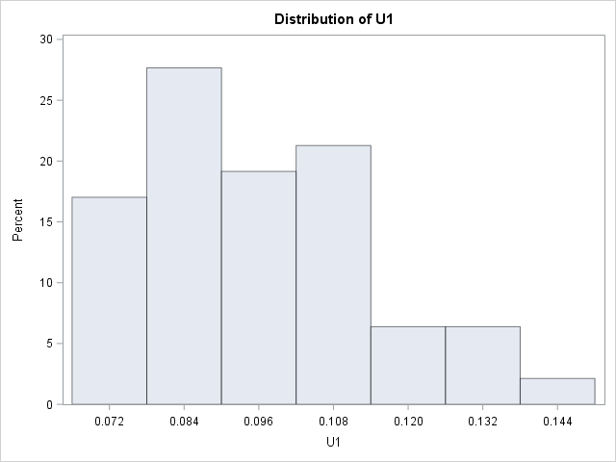

|  |
| --- |
| The SAS System |

The UNIVARIATE Procedure

Variable: U2

| **Moments** | | | |
| --- | --- | --- | --- |
| **N** | 47 | **Sum Weights** | 47 |
| **Mean** | 3.39787234 | **Sum Observations** | 159.7 |
| **Std Deviation** | 0.84454499 | **Variance** | 0.71325624 |
| **Skewness** | 0.57867686 | **Kurtosis** | 0.48783891 |
| **Uncorrected SS** | 575.45 | **Corrected SS** | 32.8097872 |
| **Coeff Variation** | 24.8551125 | **Std Error Mean** | 0.12318955 |

| **Basic Statistical Measures** | | | |
| --- | --- | --- | --- |
| **Location** | | **Variability** | |
| **Mean** | 3.397872 | **Std Deviation** | 0.84454 |
| **Median** | 3.400000 | **Variance** | 0.71326 |
| **Mode** | 3.500000 | **Range** | 3.80000 |
|  |  | **Interquartile Range** | 1.20000 |

| **Tests for Location: Mu0=0** | | | | |
| --- | --- | --- | --- | --- |
| **Test** | **Statistic** | | **p Value** | |
| **Student's t** | **t** | 27.58247 | **Pr > |t|** | <.0001 |
| **Sign** | **M** | 23.5 | **Pr >= |M|** | <.0001 |
| **Signed Rank** | **S** | 564 | **Pr >= |S|** | <.0001 |

| **Quantiles (Definition 5)** | |
| --- | --- |
| **Level** | **Quantile** |
| **100% Max** | 5.8 |
| **99%** | 5.8 |
| **95%** | 5.0 |
| **90%** | 4.3 |
| **75% Q3** | 3.9 |
| **50% Median** | 3.4 |
| **25% Q1** | 2.7 |
| **10%** | 2.4 |
| **5%** | 2.1 |
| **1%** | 2.0 |
| **0% Min** | 2.0 |

| **Extreme Observations** | | | |
| --- | --- | --- | --- |
| **Lowest** | | **Highest** | |
| **Value** | **Obs** | **Value** | **Obs** |
| 2.0 | 41 | 4.3 | 32 |
| 2.0 | 5 | 4.7 | 16 |
| 2.1 | 25 | 5.0 | 35 |
| 2.2 | 27 | 5.3 | 45 |
| 2.4 | 33 | 5.8 | 20 |

|  |
| --- |
| The SAS System |

The UNIVARIATE Procedure

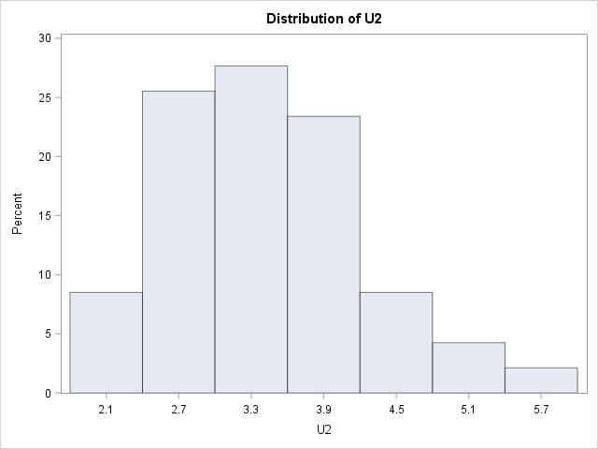

|  |
| --- |
| The SAS System |

The UNIVARIATE Procedure

Variable: Wealth

| **Moments** | | | |
| --- | --- | --- | --- |
| **N** | 47 | **Sum Weights** | 47 |
| **Mean** | 5253.82979 | **Sum Observations** | 246930 |
| **Std Deviation** | 964.909442 | **Variance** | 931050.231 |
| **Skewness** | -0.4076 | **Kurtosis** | -0.4273988 |
| **Uncorrected SS** | 1340156500 | **Corrected SS** | 42828310.6 |
| **Coeff Variation** | 18.3658299 | **Std Error Mean** | 140.746508 |

| **Basic Statistical Measures** | | | |
| --- | --- | --- | --- |
| **Location** | | **Variability** | |
| **Mean** | 5253.830 | **Std Deviation** | 964.90944 |
| **Median** | 5370.000 | **Variance** | 931050 |
| **Mode** | 5570.000 | **Range** | 4010 |
|  |  | **Interquartile Range** | 1360 |

| **Tests for Location: Mu0=0** | | | | |
| --- | --- | --- | --- | --- |
| **Test** | **Statistic** | | **p Value** | |
| **Student's t** | **t** | 37.32831 | **Pr > |t|** | <.0001 |
| **Sign** | **M** | 23.5 | **Pr >= |M|** | <.0001 |
| **Signed Rank** | **S** | 564 | **Pr >= |S|** | <.0001 |

| **Quantiles (Definition 5)** | |
| --- | --- |
| **Level** | **Quantile** |
| **100% Max** | 6890 |
| **99%** | 6890 |
| **95%** | 6730 |
| **90%** | 6370 |
| **75% Q3** | 5930 |
| **50% Median** | 5370 |
| **25% Q1** | 4570 |
| **10%** | 3950 |
| **5%** | 3820 |
| **1%** | 2880 |
| **0% Min** | 2880 |

| **Extreme Observations** | | | |
| --- | --- | --- | --- |
| **Lowest** | | **Highest** | |
| **Value** | **Obs** | **Value** | **Obs** |
| 2880 | 22 | 6370 | 29 |
| 3180 | 3 | 6570 | 11 |
| 3820 | 37 | 6730 | 4 |
| 3940 | 1 | 6740 | 26 |
| 3950 | 39 | 6890 | 6 |

|  |
| --- |
| The SAS System |

The UNIVARIATE Procedure

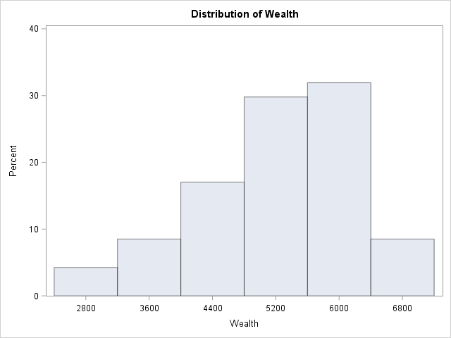

|  |
| --- |
| The SAS System |

The UNIVARIATE Procedure

Variable: Ineq

| **Moments** | | | |
| --- | --- | --- | --- |
| **N** | 47 | **Sum Weights** | 47 |
| **Mean** | 19.4 | **Sum Observations** | 911.8 |
| **Std Deviation** | 3.98960606 | **Variance** | 15.9169565 |
| **Skewness** | 0.39171094 | **Kurtosis** | -1.0393471 |
| **Uncorrected SS** | 18421.1 | **Corrected SS** | 732.18 |
| **Coeff Variation** | 20.5649797 | **Std Error Mean** | 0.58194385 |

| **Basic Statistical Measures** | | | |
| --- | --- | --- | --- |
| **Location** | | **Variability** | |
| **Mean** | 19.40000 | **Std Deviation** | 3.98961 |
| **Median** | 17.60000 | **Variance** | 15.91696 |
| **Mode** | 16.60000 | **Range** | 15.00000 |
|  |  | **Interquartile Range** | 6.30000 |

| **Tests for Location: Mu0=0** | | | | |
| --- | --- | --- | --- | --- |
| **Test** | **Statistic** | | **p Value** | |
| **Student's t** | **t** | 33.33655 | **Pr > |t|** | <.0001 |
| **Sign** | **M** | 23.5 | **Pr >= |M|** | <.0001 |
| **Signed Rank** | **S** | 564 | **Pr >= |S|** | <.0001 |

| **Quantiles (Definition 5)** | |
| --- | --- |
| **Level** | **Quantile** |
| **100% Max** | 27.6 |
| **99%** | 27.6 |
| **95%** | 26.1 |
| **90%** | 25.1 |
| **75% Q3** | 22.8 |
| **50% Median** | 17.6 |
| **25% Q1** | 16.5 |
| **10%** | 15.2 |
| **5%** | 13.9 |
| **1%** | 12.6 |
| **0% Min** | 12.6 |

| **Extreme Observations** | | | |
| --- | --- | --- | --- |
| **Lowest** | | **Highest** | |
| **Value** | **Obs** | **Value** | **Obs** |
| 12.6 | 6 | 25.1 | 39 |
| 13.5 | 19 | 25.4 | 37 |
| 13.9 | 27 | 26.1 | 1 |
| 14.4 | 41 | 26.4 | 15 |
| 15.2 | 26 | 27.6 | 22 |

|  |
| --- |
| The SAS System |

The UNIVARIATE Procedure

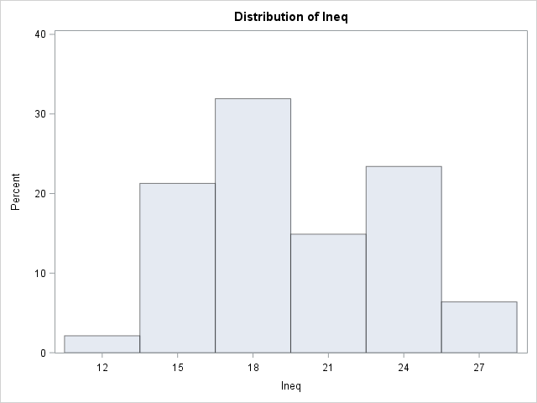

|  |
| --- |
| The SAS System |

The UNIVARIATE Procedure

Variable: Prob

| **Moments** | | | |
| --- | --- | --- | --- |
| **N** | 47 | **Sum Weights** | 47 |
| **Mean** | 0.04709138 | **Sum Observations** | 2.213295 |
| **Std Deviation** | 0.02273697 | **Variance** | 0.00051697 |
| **Skewness** | 0.942652 | **Kurtosis** | 1.1590617 |
| **Uncorrected SS** | 0.12800774 | **Corrected SS** | 0.02378062 |
| **Coeff Variation** | 48.2826597 | **Std Error Mean** | 0.00331653 |

| **Basic Statistical Measures** | | | |
| --- | --- | --- | --- |
| **Location** | | **Variability** | |
| **Mean** | 0.047091 | **Std Deviation** | 0.02274 |
| **Median** | 0.042100 | **Variance** | 0.0005170 |
| **Mode** | . | **Range** | 0.11290 |
|  |  | **Interquartile Range** | 0.02370 |

| **Tests for Location: Mu0=0** | | | | |
| --- | --- | --- | --- | --- |
| **Test** | **Statistic** | | **p Value** | |
| **Student's t** | **t** | 14.199 | **Pr > |t|** | <.0001 |
| **Sign** | **M** | 23.5 | **Pr >= |M|** | <.0001 |
| **Signed Rank** | **S** | 564 | **Pr >= |S|** | <.0001 |

| **Quantiles (Definition 5)** | |
| --- | --- |
| **Level** | **Quantile** |
| **100% Max** | 0.119804 |
| **99%** | 0.119804 |
| **95%** | 0.088904 |
| **90%** | 0.083401 |
| **75% Q3** | 0.054902 |
| **50% Median** | 0.042100 |
| **25% Q1** | 0.031201 |
| **10%** | 0.020700 |
| **5%** | 0.016201 |
| **1%** | 0.006900 |
| **0% Min** | 0.006900 |

| **Extreme Observations** | | | |
| --- | --- | --- | --- |
| **Lowest** | | **Highest** | |
| **Value** | **Obs** | **Value** | **Obs** |
| 0.006900 | 36 | 0.083401 | 3 |
| 0.015801 | 4 | 0.084602 | 1 |
| 0.016201 | 11 | 0.088904 | 42 |
| 0.019099 | 19 | 0.089502 | 22 |
| 0.020700 | 35 | 0.119804 | 18 |

|  |
| --- |
| The SAS System |

The UNIVARIATE Procedure

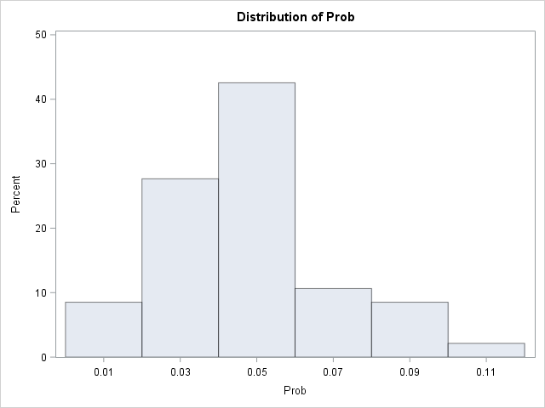

|  |
| --- |
| The SAS System |

The UNIVARIATE Procedure

Variable: Time

| **Moments** | | | |
| --- | --- | --- | --- |
| **N** | 47 | **Sum Weights** | 47 |
| **Mean** | 26.5979213 | **Sum Observations** | 1250.1023 |
| **Std Deviation** | 7.08689519 | **Variance** | 50.2240835 |
| **Skewness** | 0.39620564 | **Kurtosis** | -0.194922 |
| **Uncorrected SS** | 35560.4304 | **Corrected SS** | 2310.30784 |
| **Coeff Variation** | 26.6445453 | **Std Error Mean** | 1.03372991 |

| **Basic Statistical Measures** | | | |
| --- | --- | --- | --- |
| **Location** | | **Variability** | |
| **Mean** | 26.59792 | **Std Deviation** | 7.08690 |
| **Median** | 25.80060 | **Variance** | 50.22408 |
| **Mode** | 16.69990 | **Range** | 31.80080 |
|  |  | **Interquartile Range** | 9.40040 |

|  |
| --- |
| **Note: The mode displayed is the smallest of 2 modes with a count of 2.** |

| **Tests for Location: Mu0=0** | | | | |
| --- | --- | --- | --- | --- |
| **Test** | **Statistic** | | **p Value** | |
| **Student's t** | **t** | 25.73005 | **Pr > |t|** | <.0001 |
| **Sign** | **M** | 23.5 | **Pr >= |M|** | <.0001 |
| **Signed Rank** | **S** | 564 | **Pr >= |S|** | <.0001 |

| **Quantiles (Definition 5)** | |
| --- | --- |
| **Level** | **Quantile** |
| **100% Max** | 44.0004 |
| **99%** | 44.0004 |
| **95%** | 37.5998 |
| **90%** | 37.0994 |
| **75% Q3** | 30.9014 |
| **50% Median** | 25.8006 |
| **25% Q1** | 21.5010 |
| **10%** | 17.6000 |
| **5%** | 16.6999 |
| **1%** | 12.1996 |
| **0% Min** | 12.1996 |

| **Extreme Observations** | | | |
| --- | --- | --- | --- |
| **Lowest** | | **Highest** | |
| **Value** | **Obs** | **Value** | **Obs** |
| 12.1996 | 42 | 37.0994 | 22 |
| 16.0997 | 47 | 37.4011 | 35 |
| 16.6999 | 46 | 37.5998 | 21 |
| 16.6999 | 38 | 41.6000 | 11 |
| 17.6000 | 24 | 44.0004 | 36 |

|  |
| --- |
| The SAS System |

The UNIVARIATE Procedure

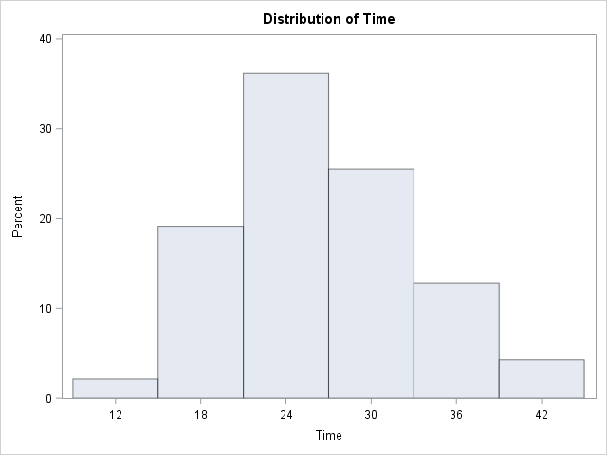

|  |
| --- |
| The SAS System |

The UNIVARIATE Procedure

Variable: Crime

| **Moments** | | | |
| --- | --- | --- | --- |
| **N** | 47 | **Sum Weights** | 47 |
| **Mean** | 905.085106 | **Sum Observations** | 42539 |
| **Std Deviation** | 386.762697 | **Variance** | 149585.384 |
| **Skewness** | 1.12469778 | **Kurtosis** | 1.19171515 |
| **Uncorrected SS** | 45382343 | **Corrected SS** | 6880927.66 |
| **Coeff Variation** | 42.7321911 | **Std Error Mean** | 56.4151375 |

| **Basic Statistical Measures** | | | |
| --- | --- | --- | --- |
| **Location** | | **Variability** | |
| **Mean** | 905.0851 | **Std Deviation** | 386.76270 |
| **Median** | 831.0000 | **Variance** | 149585 |
| **Mode** | 849.0000 | **Range** | 1651 |
|  |  | **Interquartile Range** | 419.00000 |

|  |
| --- |
| **Note: The mode displayed is the smallest of 2 modes with a count of 2.** |

| **Tests for Location: Mu0=0** | | | | |
| --- | --- | --- | --- | --- |
| **Test** | **Statistic** | | **p Value** | |
| **Student's t** | **t** | 16.0433 | **Pr > |t|** | <.0001 |
| **Sign** | **M** | 23.5 | **Pr >= |M|** | <.0001 |
| **Signed Rank** | **S** | 564 | **Pr >= |S|** | <.0001 |

| **Quantiles (Definition 5)** | |
| --- | --- |
| **Level** | **Quantile** |
| **100% Max** | 1993 |
| **99%** | 1993 |
| **95%** | 1674 |
| **90%** | 1555 |
| **75% Q3** | 1072 |
| **50% Median** | 831 |
| **25% Q1** | 653 |
| **10%** | 508 |
| **5%** | 439 |
| **1%** | 342 |
| **0% Min** | 342 |

| **Extreme Observations** | | | |
| --- | --- | --- | --- |
| **Lowest** | | **Highest** | |
| **Value** | **Obs** | **Value** | **Obs** |
| 342 | 27 | 1555 | 8 |
| 373 | 31 | 1635 | 2 |
| 439 | 22 | 1674 | 11 |
| 455 | 45 | 1969 | 4 |
| 508 | 46 | 1993 | 26 |

|  |
| --- |
| The SAS System |

The UNIVARIATE Procedure

